**Political Parties**

**A. Vocabulary.** Match each key term with its definition. Each key term in the word bank will only be used once.

|  |  |  |  |  |
| --- | --- | --- | --- | --- |
| political party | write-in candidate | public policy | minority party | third party |
| platform | political views | ballot access | candidate | majority party |

|  |  |
| --- | --- |
| **DEFINITION** | **KEY TERM** |
| 1. Allowing a political party to put a candidate on the ballot | Ballot access |
| 2. A person’s ideas about how government should run and how issues should be solved |  |
| 3. A candidate whose name a voter must hand-write on the ballot |  |
| 4. Political party with the most elected members |  |
| 5. The stand the government takes about how issues should be handled |  |
| 6. A political party other than Republican or Democratic |  |
| 7. An organized group of people who share similar political views and work to influence government |  |
| 8. Set of statements describing a party’s views on major issues |  |
| 9. Political party that does not have a majority of the elected  members |  |
| 10. A person running for political office |  |

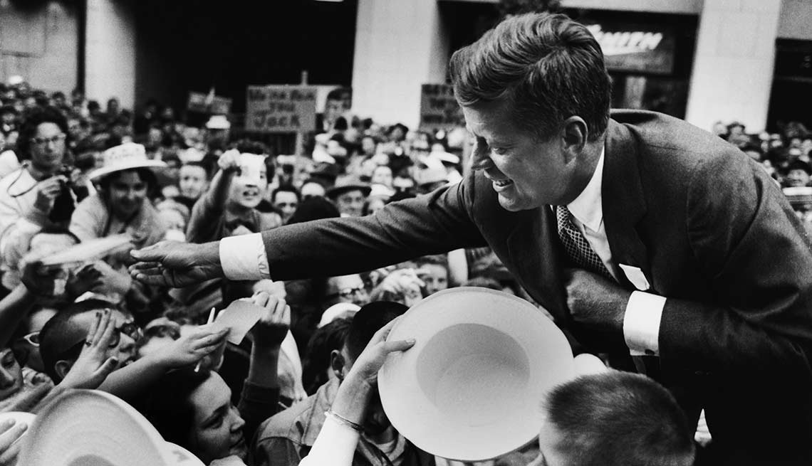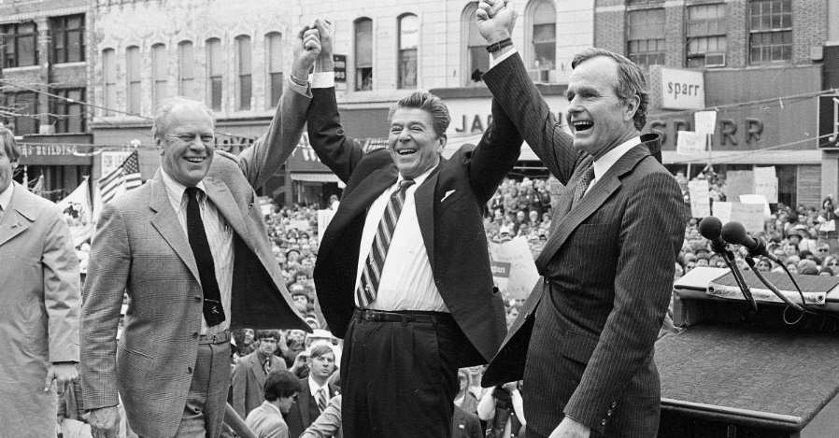

**B. Short Answer.** Read each question and give a short response to answer it. The questions go in order in the reading.

11) Why do people organize into political parties?

People organize into political parties because:

12) The United States is largely a two-party system. What are the two major parties?

13) Why might someone choose to be politically independent instead of joining a party?

14) Why do the major parties tend to keep their platforms as broad and general as possible?

15) How do political parties help to support candidates running for office?

16) True or False?: In the U.S. Congress and most state legislatures, Republicans and Democrats are split into a majority party and a minority party.

17) The President does not make the laws, but can play a role in the lawmaking and governing process – how?

18) Why should you learn about candidates and issues from multiple sources and not just rely on political parties for this information?

 

**C. Registered Voter!** Read each registered voter’s statement. Then, decide how each voter is probably registered. Be careful—some have more than one correct possibility! Mark all that you think could apply.

|  |  |  |
| --- | --- | --- |
| Write the parties that they could belong to in the box below: | Write the party that they could belong to in the box below: | Write the party that they could belong to in the box below: |
| Independent  Third Party |  |  |
|  |  |  |
| Write the parties that they could belong to in the box below: | Write the party that they could belong to in the box below: | Write the party that they could belong to in the box below: |
|  |  |  |
|  |  |  |